**4. Introduction to NLB TLS with k8s Service**

**Architectural diagram of NLB (aws perspective)**

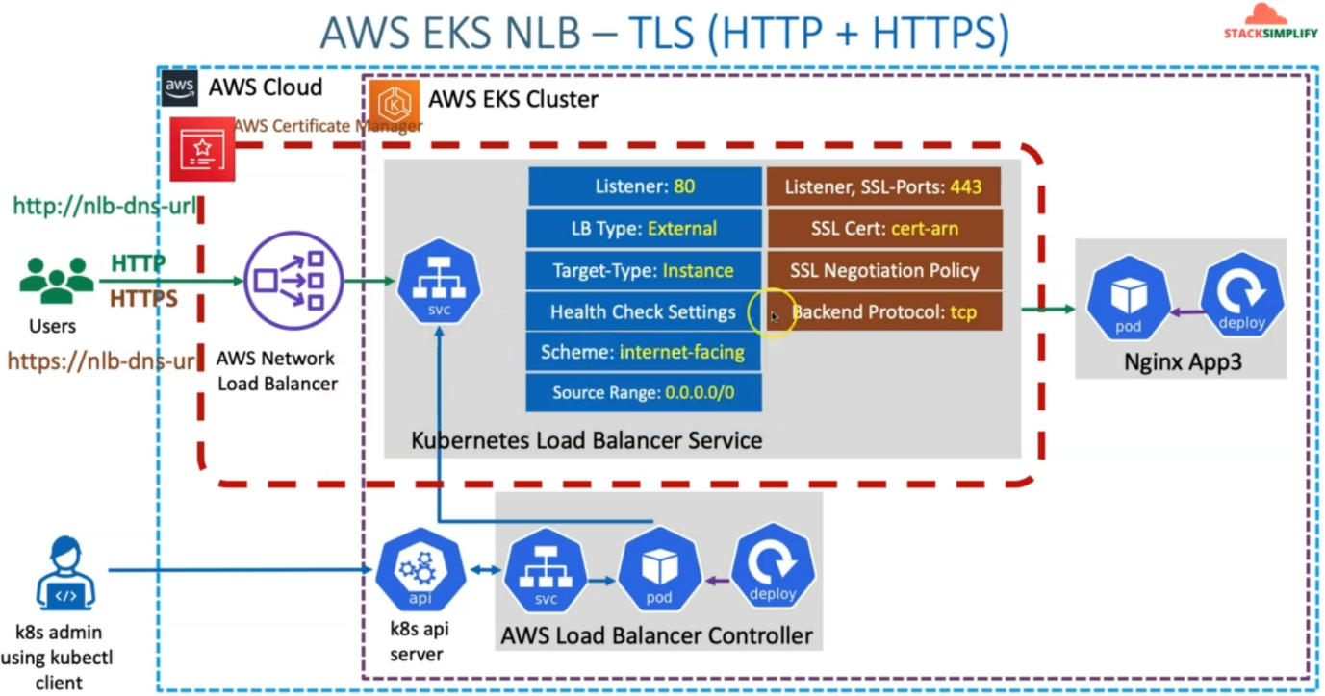

--- we are going to learn about network load balancer, TLS or SSL using Kubernetes service.

--- if you see here, earlier, we have seen the Kubernetes service with annotations related to NLB with listeners port 80 and all standard annotations, which is required for creating that network load balancer using the Kubernetes service.

--- now we are going to add additional things here, which is nothing but the listener's required and

SSL annotations required for us. the listener is nothing but your service-related port, which is Port 80. It’s your target port and your service port going to be 443.

--- In addition, you are also going to define SSL ports, annotation and SSL certificate annotation, which is where you are going to update your SSL certificate arn from your aws certificate manager.

--- you'll also define the SSL negotiation policy and this SSL negotiation policy. You can get it from here. <https://docs.aws.amazon.com/elasticloadbalancing/latest/network/create-tls-listener.html#describe-ssl-policies>

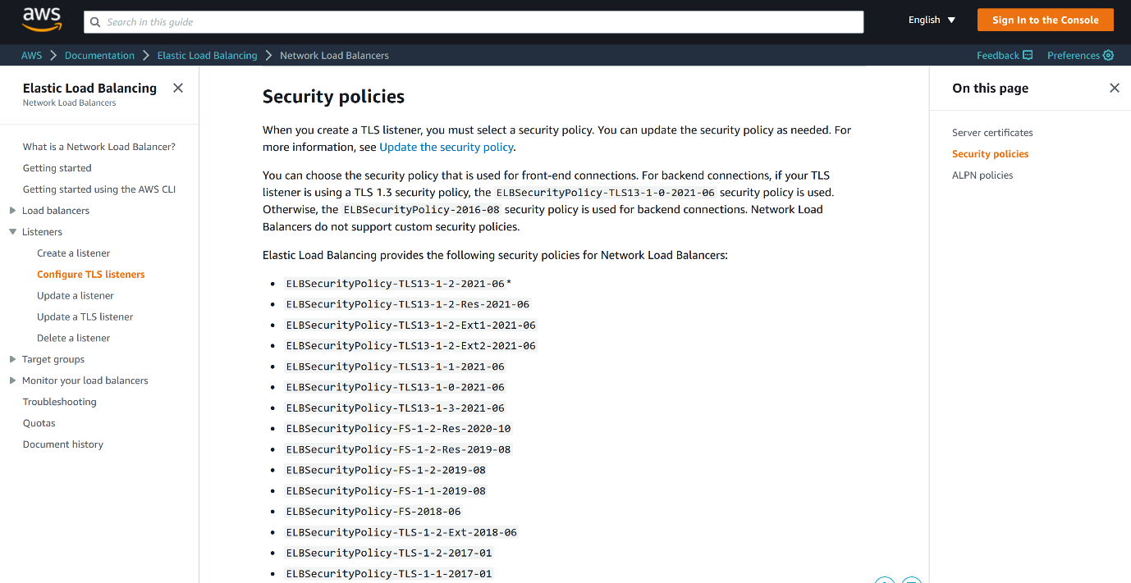

--- Backend protocol, the backend protocol annotation supports TCP and TLS. the communication from this network load balancer to this backend application nginx App3 should be TCP or TLS. So that need to be decided.

--- So, if your backend application is listening on SSL and you want the communication from this network load balancer to your backend pod with SSL only or TLS only,

--- In our case, our backend pod is listening on the container. ours is going to be TCP.

--- one important annotation still we did not discuss is SSL Port 443. what does this annotation does is, Specify this annotation if you need both TLS and non-TLS listeners on the same load balancer?

--- if you don't specify this annotation, you don't get the non-TLS annotations, Only TLS annotations are supported.

**Network design (kubernetes perspective)**

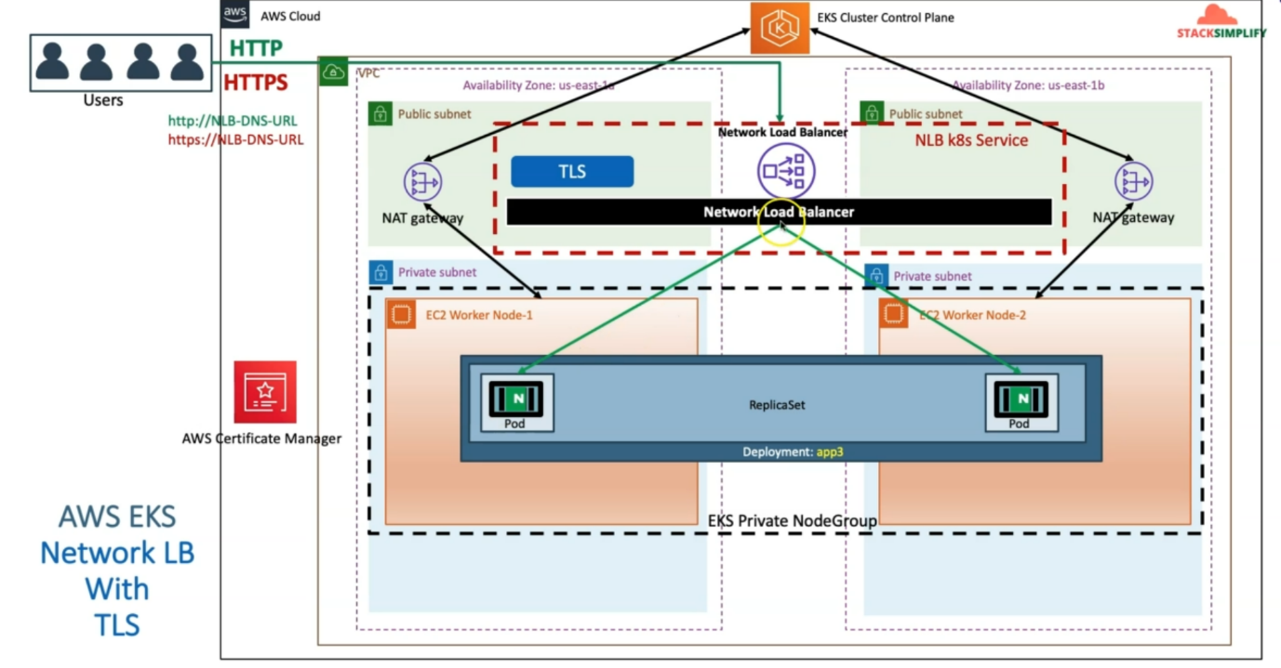

--- in aws cloud, whenever we create EKS cluster control plane, it has created VPC for us and public and private subnet and we created a EKS Private Node group and deployed the app3 application here and also deployed the Kubernetes service with NLB annotations so that it created a network load balancer.

--- In addition, we created a certificate manager related SSL certificate Inside that wildcard certificate *.stacksimplify.com and associated that respective certificate arn in our TLS related annotations in our network load balancer so that this network load balancer can terminate the SSL on this network load balancer.

--- you can access with both http and https.

**AWS EKS NLB – Annotations**

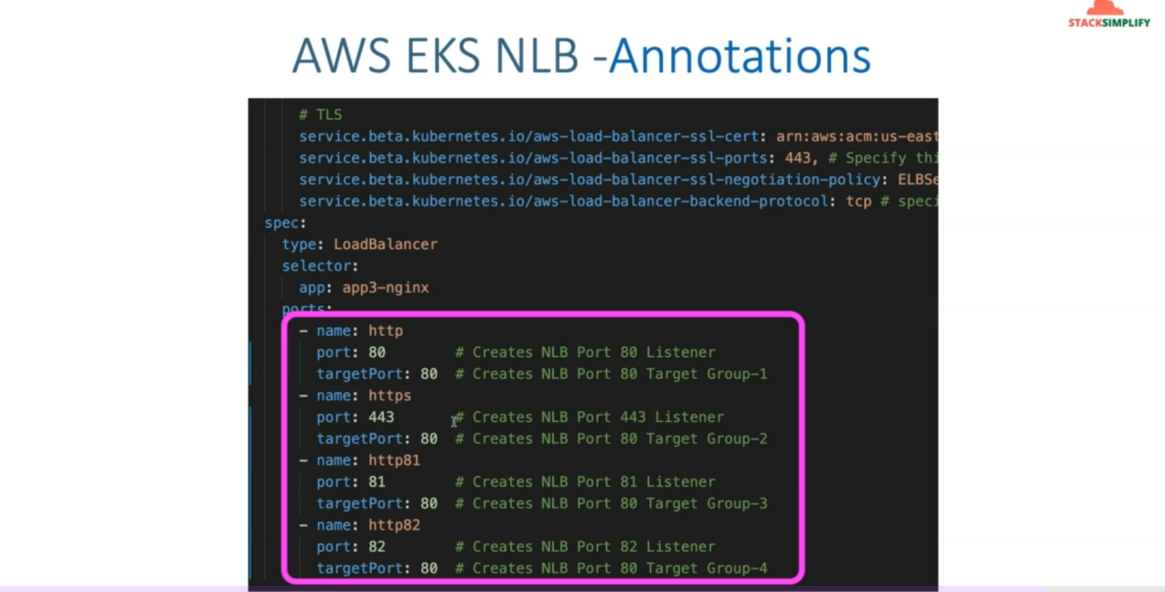

--- this is the result in AWS load balancer section.

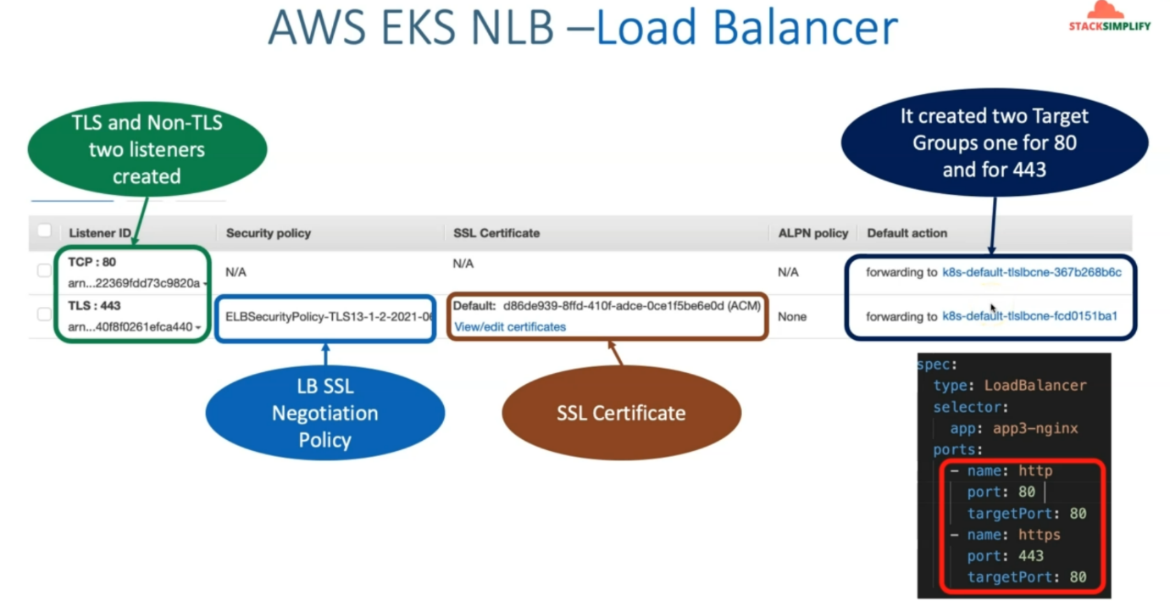

--- target groups.

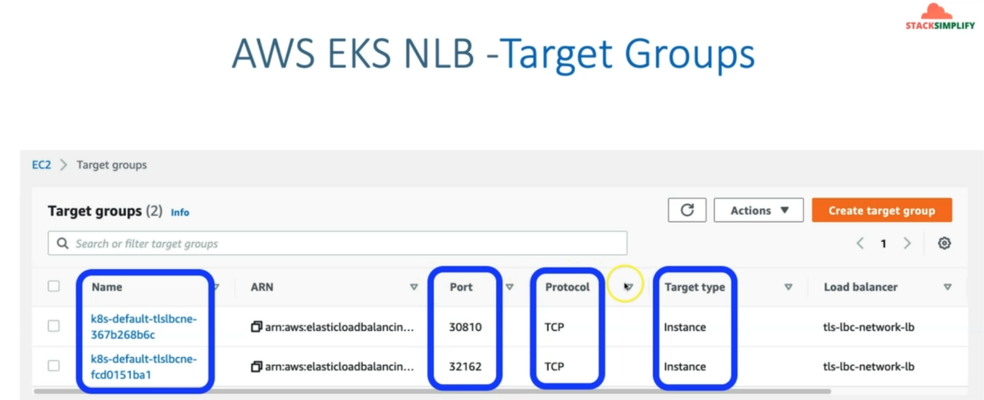

--- the target type is instance mode.

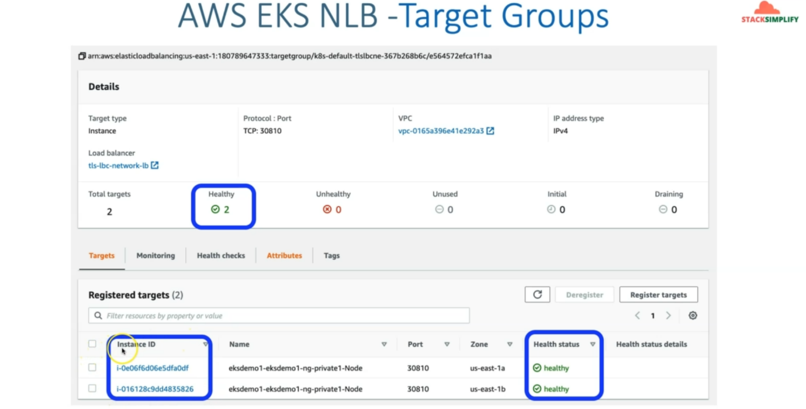

--- worker nodes registered here.

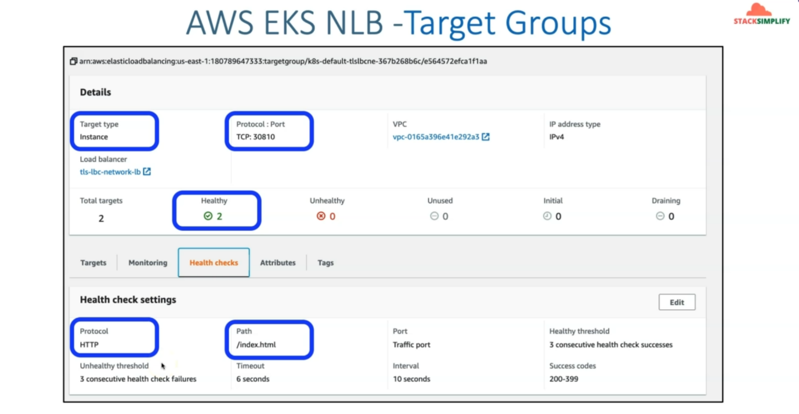

--- this is the health checks and the protocol is http and path are /index.html.